The XXXVIII International School of Hydraulics, 21-24 May 2019, Łąck, Poland
Instruction for Authors for preparation of Abstract of the paper
or poster/presentation prepared
for the XXXVIII International School of Hydraulics
(14 pt Times New Roman, bold, centred)
Monika KALINOWSKA¹ and Name SURNAME ² (10 pt Times New Roman, centred)
¹ Institute of Geophysics Polish Academy of Sciences (10 pt Times New Roman, centred)
Ks. Janusza 64, 01-452 Warsaw, Poland (10 pt Times New Roman, centred)
email: mkalinow@igf.edu.pl (10 pt Times New Roman, centred)
² Second author Name of Institute (if the second author has different affiliation)
Second author address (if the second author has different affiliation)
email: name2@igf.edu.pl (if the second author has different affiliation)
Abstract
The typing instructions are provided to the Authors for the preparation of the Abstract of their paper or poster/presentation to be included in the Conference Book of Abstracts of the XXXVIII International School of Hydraulics.
The Abstract must be written in English and must be formatted as single body text, without breaking it into sections. The abstract is 10-point Times New Roman font and is fully justified. Use “SH Abstract-text” style for this paragraph. Use the word “Abstract” as the title, 10-point Arial font, centred (“SH Abstract” style). Note that the first line of the paragraph of the abstract is indented by 1 cm. The paper size is A4 (210 x 297 cm) with a 4 cm margin at the top, 4 cm margin at the bottom and 3 cm margins on the left and right. Lines are single spacing. Author names and affiliations are to be centred and printed in 10-point font. Use the “SH Author” style to type the author name, “SH Institute” style to type the name of Institute and the “SH Address” style to type the full postal address and email. If the co-authors have the same affiliation as the first author, type the affiliation ones only. We encourage to add to the abstract one of the key images/figures/graphs to advertise your poster or presentation.

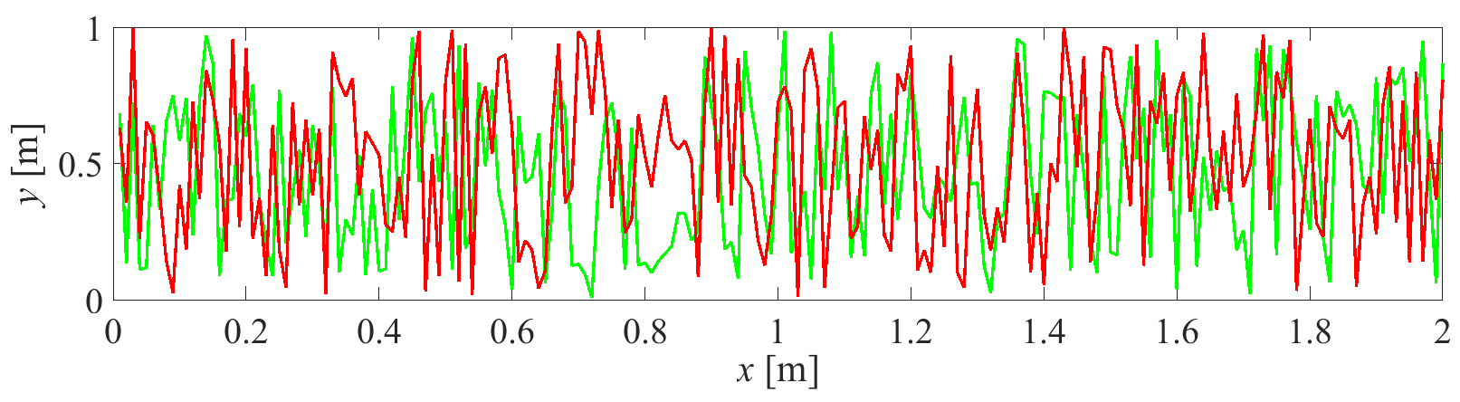
Fig. 1. Figure caption should be placed below the figure (8.5 pt Times New Roman, centred).
The Abstract should be prepared according to the instruction and must be sent to the conference secretariat electronically using the form: https://sh2019.igf.edu.pl/paper_submission.
The maximum length for the Abstract is TWO template pages. The Abstract should be written in a way to provide a complete summary of the work carried out. We reserve the right to make minor language corrections and editorial alterations. In case of any problems, please contact us by email: sh2019@mazurkas.pl.

